Recognized pattern: FakeDoc_variety1

The pattern has a form:

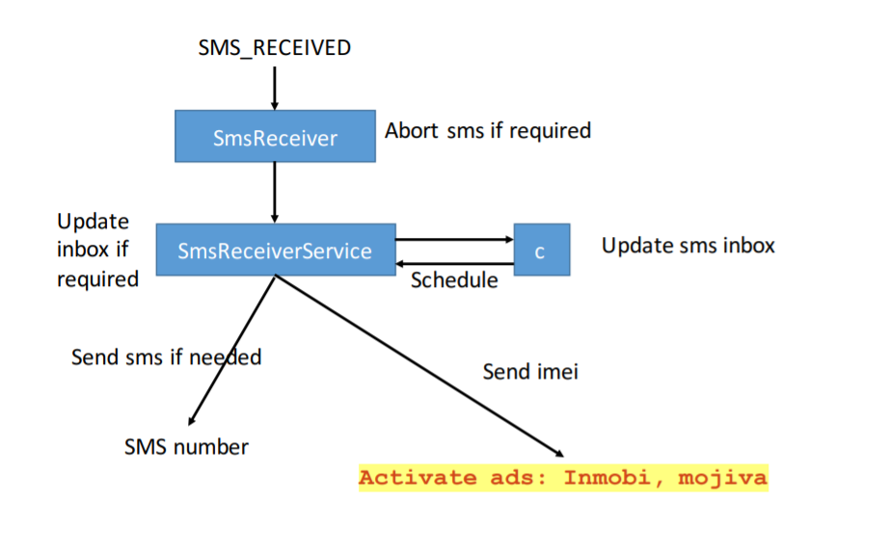

Sample app corresponding name: Battery SuperCharger

The name corresponding to this app: Battery level

For functional modules:

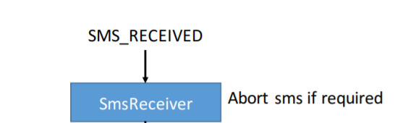

Corresponding to the key code in sample app:

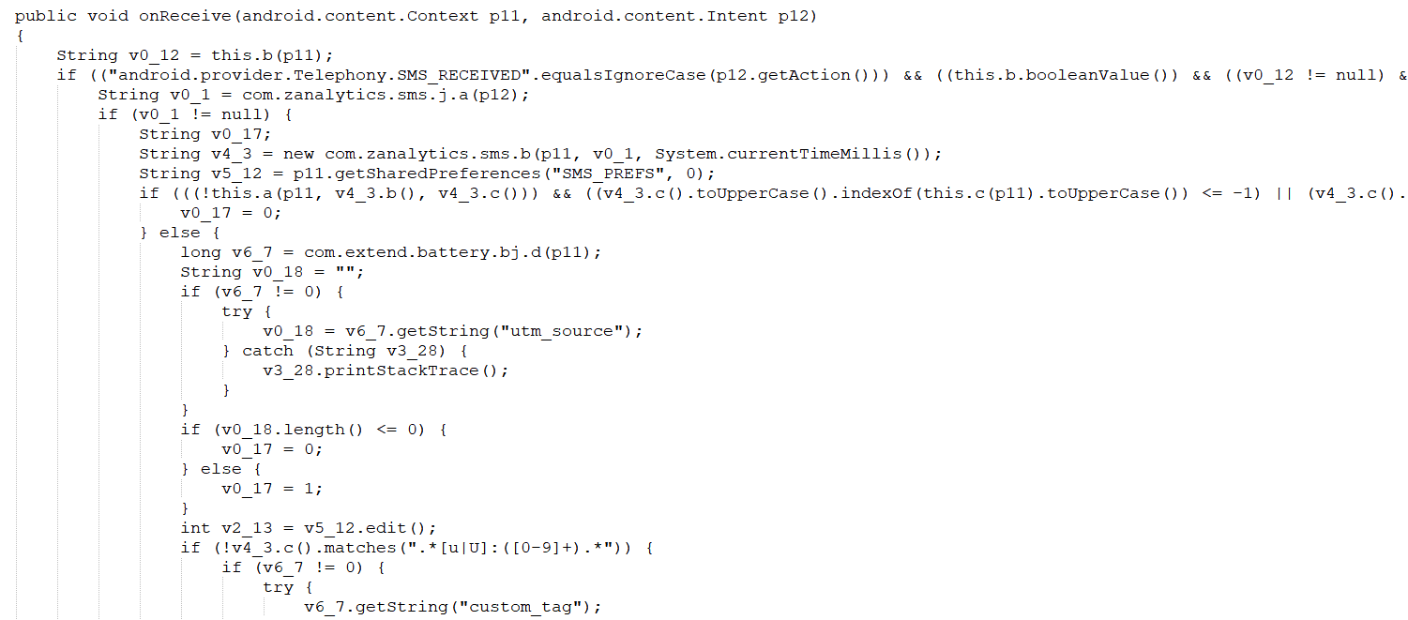

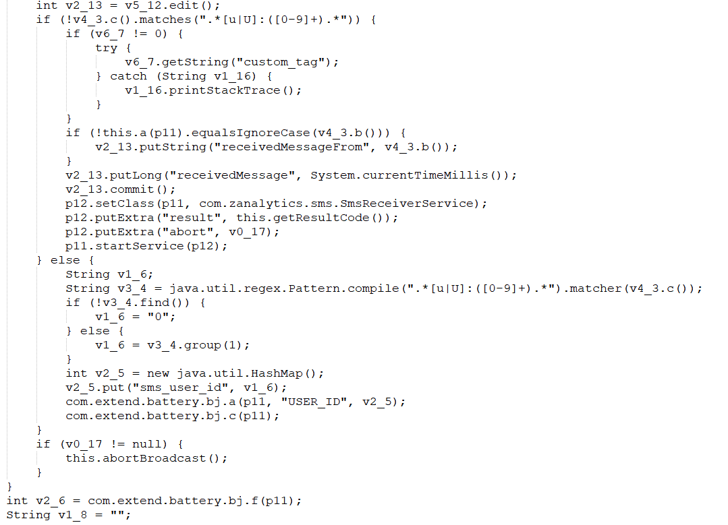

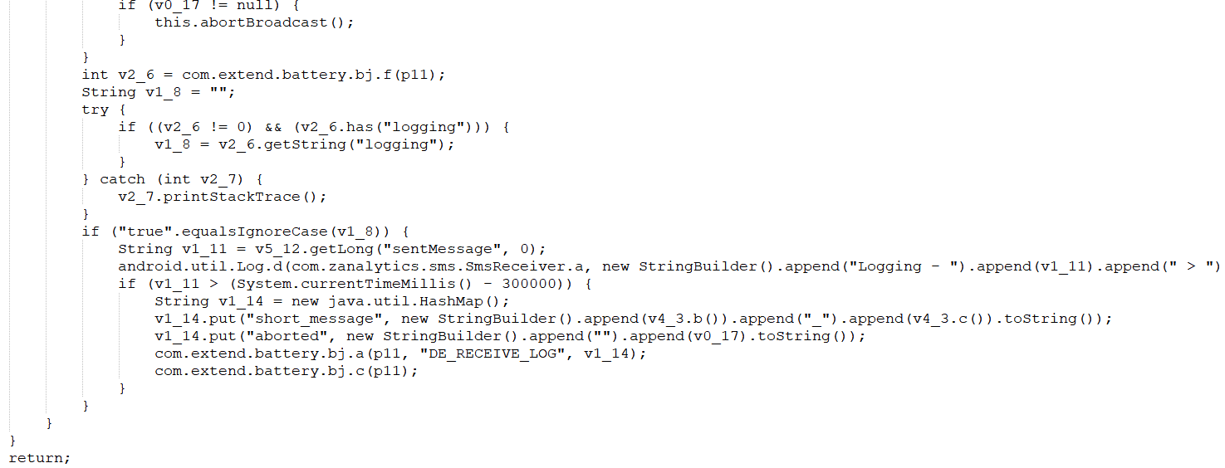

Corresponding to the key code in this app:

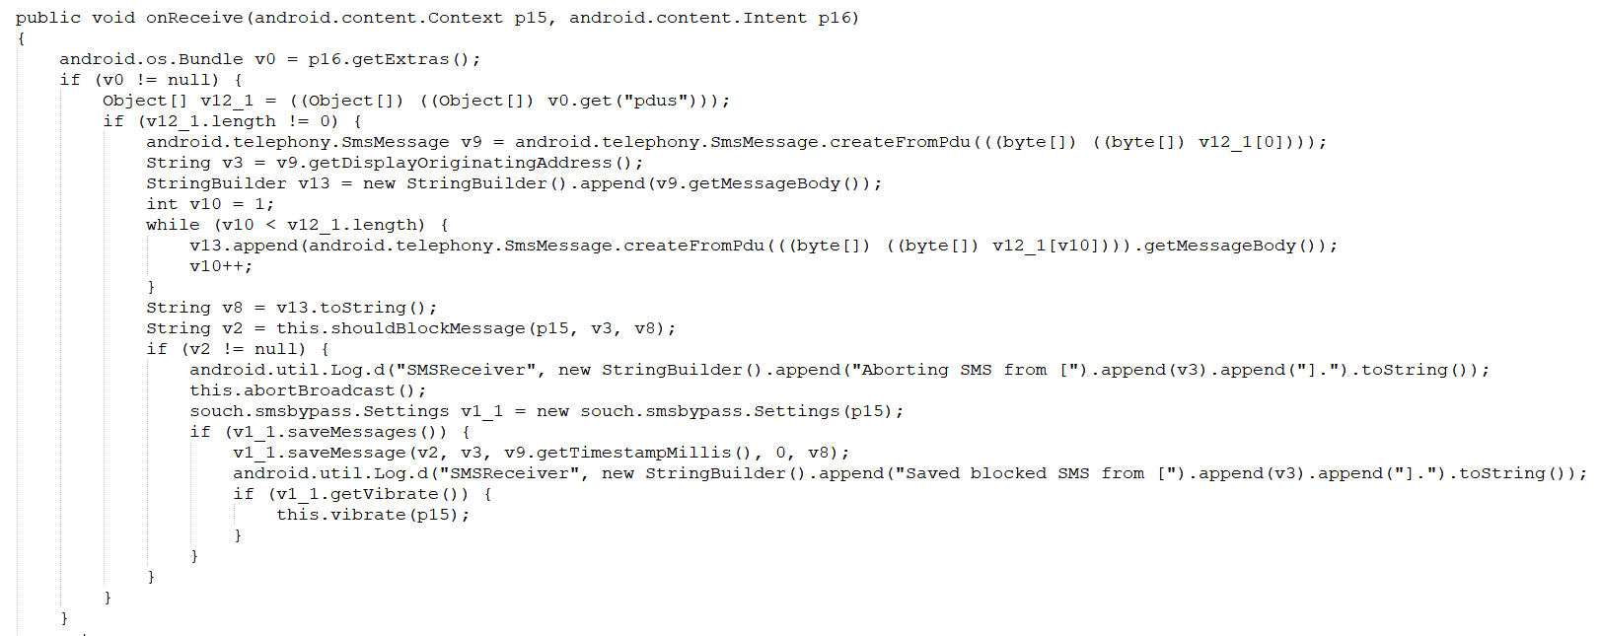

For functional modules:

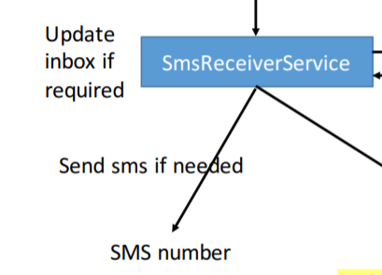

Corresponding to the key code in sample app:：

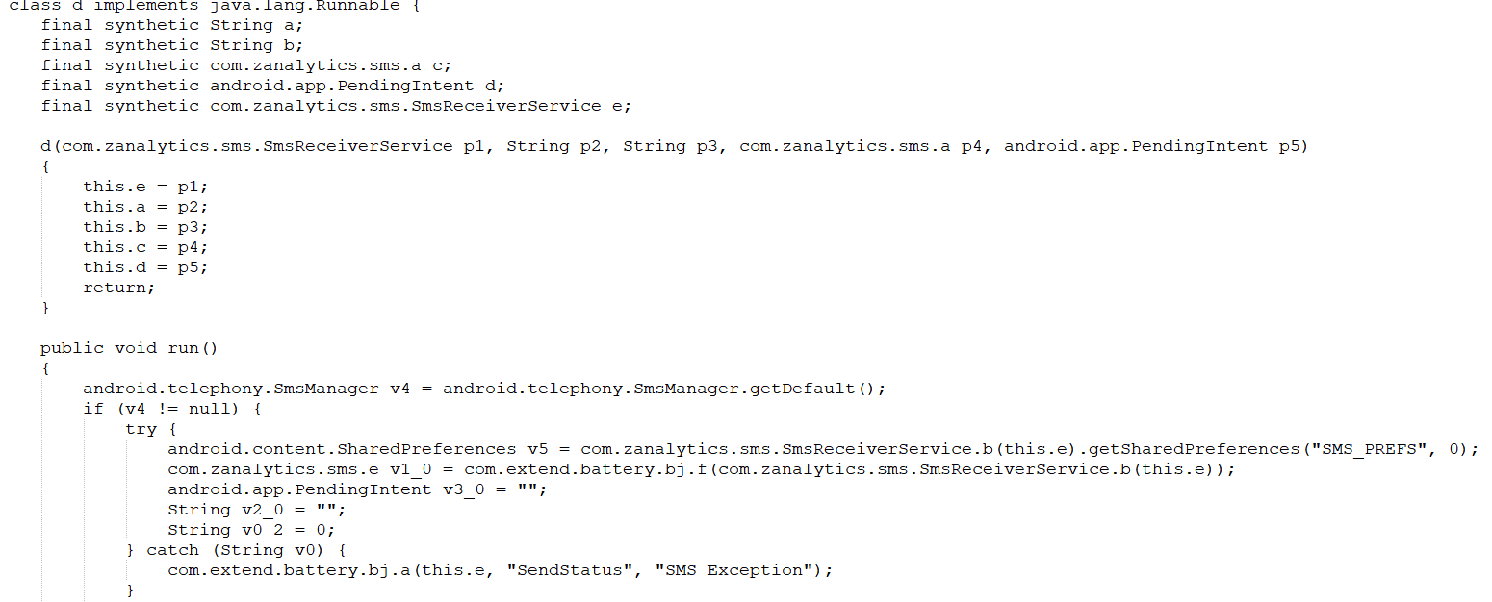

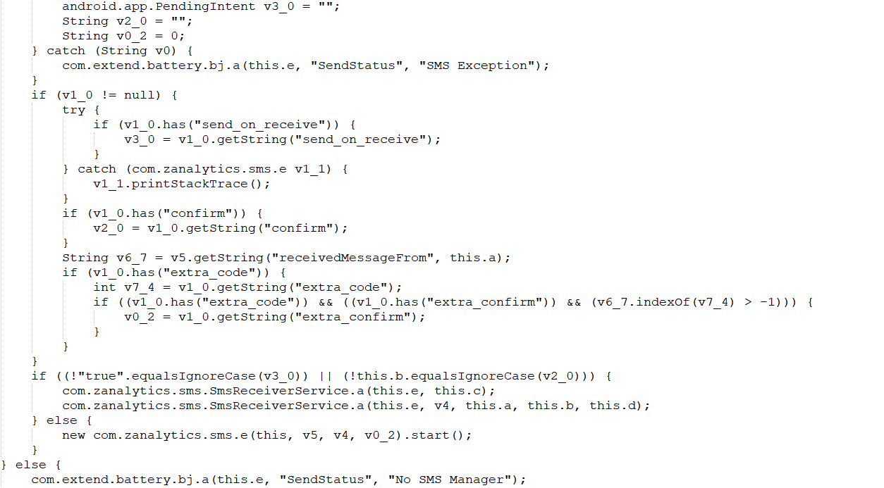

Corresponding to the key code in this app:

